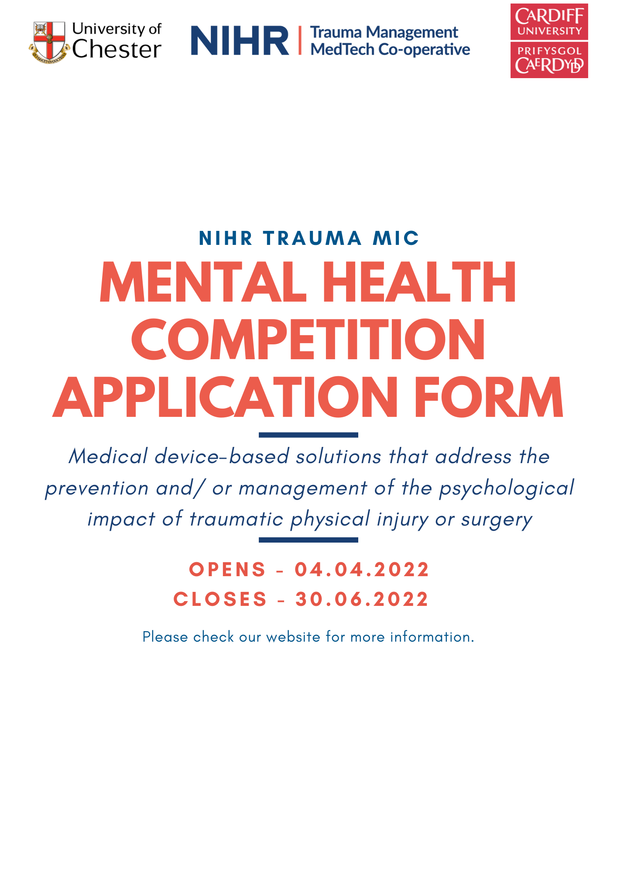
Application
Please complete this application form and email to TraumaMIC@uhb.nhs.uk to submit your application, the team will acknowledge receipt of your submission within 2 working days.
We recommend completing the questions in an alternative word document and copy and pasting your final responses into the text boxes. The maximum word count per question is indicated in brackets.
Name
Job Title
Host Organisation/ Company Name
Company Registration Number (if applicable)
Organisation Address and Postcode
Name of Innovation
Email Address
Contact Telephone Number
Web Address
Are you an SME? | ☐Yes  ☐No  An SME is defined as an enterprise or company satisfying 2 or more of the following conditions:  Headcount Turnover Balance Sheet Total  <250 <£36M <£18M
Would you like to sign up to the Trauma MIC Newsletter? | ☐Yes  ☐No

- Please provide a description of the medical device/ technology and how this will improve the prevention or treatment of the psychological impact following traumatic physical injury or surgery. (1000 words)

- Please provide a short lay written description of the medical technology and how it will improve the prevention or treatment of the psychological impact following traumatic physical injury or surgery. (250 words)

- What is the current stage of the medical device/ technology?

- Does the device have regulatory approval?
☐Yes
☐No
Comment:
- Please provide a summary of what support you would like from the NIHR Trauma MIC if you were successful? (500 words)

- Please describe the expertise and experience of your team, as well as any previous partnerships you wish to disclose. (300 words)

- Are you available on the 25th August for a panel interview if successful following shortlisting?
☐Yes
☐No

