NIHR Trauma Management Research Centre –
Patient and Public Involvement strategy

Contents
P1 – Statement of purpose and objectives
P2 - NIHR Trauma Management Research Centre Summary
P2 - Background to Patient and Public Involvement
P3 - How Involvement activities will be supported within the MIC
P6 - How will we involve more people in the MIC?
P6 - How are we going to start involving people in the research process?
P7 - How are we going to involve people at other stages of the research process?
P7 - How will we know if involvement is making a difference?
P8 - Funding
P8 - Who is leading this work?

Statement of purpose and objectives

The purpose of this strategy is to ensure that a meaningful and impactful level of public and patient involvement takes place within the Trauma Management Support Centre. This aim will be achieved by meeting the following objectives:
- Establish and recruit to a PPI group of up to 50 members
- Define purpose and activities of this group and sub-groups
- Ensure regular and transparent communication between the Centre and PPI Group members
- Promote awareness and understanding of the group to researchers, clinicians, patients, their carers, and other key stakeholders such as affiliated charities
- Establish clear links from the PPI Group into the Governance structure of the Centre
- Establish links with other relevant PPI groups and networks
- Provide training and support to enable members to fulfil their role effectively
- Undertake evaluation activities to assess the impact of involvement on the work of the Centre on an ongoing basis
- Reimburse members of the PPI Group appropriately to reflect the value of their contribution to the work of the Centre

NIHR Trauma Management Research Centre Summary

The remit of the Centre is to support the research of new medical devices and healthcare technologies in order to improve the management of trauma patients from the point of injury through to stabilisation and recovery. The Centre is funded by the National Institute for Health Research (hereafter referred to as NIHR) and has a national remit, though it is based in Birmingham. The official name of the Centre is the NIHR Medtech and In vitro diagnostic Co-operative in Trauma Management (hereafter referred to as the MIC). The MIC is hosted by University Hospitals Birmingham NHS Foundation Trust (hereafter referred to as UHB) which is itself one of the UK Major Trauma Centres. UHB is also home to the Royal Centre for Defence Medicine and a Regional Burns Centre.

New medical devices and technology are likely to be key to improving survival for trauma patients, reducing long-term disability and reducing pain and suffering. The MIC will address three clinical themes; 1) Immediate response to injury at the scene and hospital stabilisation; 2) tissue repair and surgical reconstruction and; 3) re-enablement and rehabilitation. The main success criteria for the MIC will be the numbers of new medical devices and technologies that benefit trauma patients that are ready for adoption by the NHS.

Patient and Public Involvement activities are central to the work of the MIC and this strategy sets out how the MIC will fulfil its involvement responsibilities.

Background to Patient and Public Involvement

The NIHR has a dedicated department, called INVOLVE, to support researchers and research centres in their involvement activities. INVOLVE has developed various principles and guidelines for researchers and research centres and these form the basis for our approach to Involvement activities. (See next section for more information.)

There are different terms used by INVOLVE to explain the ways in which patients and members of the public might come into contact with research as follows:
Participation – where people take part in a research study, as a research subject
Involvement – where patients and members of the public help researchers and research centres improve the quality of their research by giving advice and guidance
Engagement – where information and knowledge about research is provided to people in order to develop an interest in, and understanding of, research among the public

This strategy is focused on Involvement work and while the MIC will engage with the public about its research and people will participate in research studies, these activities are not included in this strategy.

Hereafter when using the term ‘people’ in this document, we include patients, potential patients, carers and people who use health and social care services as well as people from organisations that represent people who use services, and members of the public.

How Involvement activities will be supported within the MIC

In order to make the most of the resources available for involvement activities, and to prevent people being asked more than once to help with similar activities, the MIC has joined forces with another research centre which is closely aligned to its interests – the Surgical Reconstruction and Microbiology (Trauma) Research Centre (SRMRC) which is also funded by the NIHR and hosted by UHB. The SRMRC has an established PPI group - the ABC Group (Accident, Burns and Critical Care) and this group will be renamed to reflect the joint endeavour and proactively expanded so that it can provide a ‘pool’ of about 50 people who can take part in a range of activities across both Research Centres.

The diagram below shows how this ‘pool’ of people within the LIG will be able to take part in different sub-groups and activities. Central to the structure is the Reference Panel. This panel will consist of members who will all be patients with experience of the conditions covered by both research centres or carers of people who have such experiences. The panel will fulfil a number of roles but their main activities will be providing feedback to researchers on grant proposals and research ideas; and organising activities for specific projects, once funding has been approved – the aim being for the group to facilitate a better understanding of the potential and impact of research from the patient/carer perspective. The Reference Panel will meet on a bi-monthly basis, starting in November 2018.

The LIG as a whole will develop and guide involvement activities for research across both Centres in a more generic way, advising on how the Research Centres communicate information on their research activities, including opportunities for people to take part; identifying training needs for members; help to develop the involvement strategy across both Research Centres; and provide formal feedback to the Research Centres on involvement activities and any issues that arise as a result of these activities. The LIG as a whole will meet biannually but the activities of the group will be conducted on an ongoing basis by virtual means i.e. email correspondence, as required.

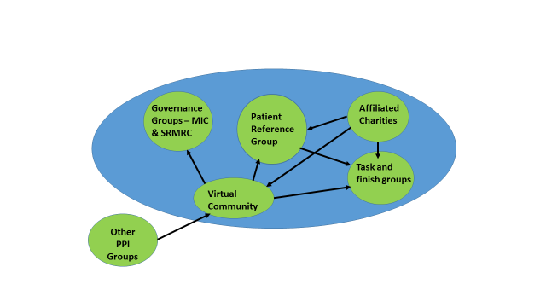

Across the organisations that are partners in the Research Centres, there are other PPI groups that might have an interest in the work of the MIC from time and time and the LIG will play a role in establishing links with these groups and liaising with them as and when necessary. There are also organisations such as charities and patient support groups that have an interest in trauma research and representatives of these groups may have an interest in either being a member of the LIG, or taking part in specific projects that are relevant to their organisations. The LIG will also play a role therefore in helping to develop and maintain links with these groups.

A representative of the LIG Group will also provide feedback on involvement activities, and raise any issues of concern to the operational and management groups which form part of the necessary governance structure for both Research Centres. The representative will take information back to members of the LIG, as necessary.

There are many activities that people can be involved with throughout the lifecycle of a research project and the LIG members can decide how, when, how often and with what, they might like to get involved. For example, it is quite usual now for some research proposals to have a co-applicant who is not an academic or a clinician but a patient, or member of the public, who has a specific insight into the topic of the research. Co-applicants can help researchers think through what they might be asking research participants to become involved with and whether this is feasible or too burdensome for some people.

People can also make a very valuable contribution to the information that each research project must provide to potential participants, in order to advise them of what the research will entail. These patient information sheets are not only vital in ensuring that people understand exactly what will be required of them, but are also vital in attracting people to become participants, so how they are worded and presented and targeted at potential participants is crucial to the success of any research project.

It is expected that the LIG Reference Group members will decide what sort of activities are appropriate for each research project and would encourage fellow members of the LIG to volunteer to take part in these activities as the opportunities arise.

Not everyone is able to attend meetings or workshops in person and therefore the mechanisms to enable involvement through virtual means will be established. For example, people can be emailed with information sheets to comment on electronically, or people could join meetings via Skype or teleconferencing facilities. This means that people can be involved in the work of the LIG without having to live locally.

How will we involve more people in the MIC?

It is important that we have a diverse and vibrant group of people who are members of the LIG and who are interested in taking part in specific involvement activities, or being members of the Patient Reference Group, so we can have a wide range of views and experiences to draw on. In order to increase the number of people who are members of the Group, we will undertake the following activities as a minimum:
- Promote the LIG and its work through the websites and newsletters for both Research Centres and through the website and newsletters of partner organisations including UHB and charitable organisations
- Promote the LIG through posters and leaflets displayed in relevant clinic and outpatient spaces, or other venues where people who have an interest in, or experience of, physical trauma, may attend i.e. Military and charitable organisations
- Attend events to speak to patient/public groups about the work of the LIG and the research undertaken by the MIC and SRMRC

We expect that the LIG itself will also play a key role in helping us to grow our PPI membership by recommending additional activities and ways to generate interest.

How are we going to start involving people in the research process?

Too often, research happens without people having a say in what topics are important to them and what they think should be the basis of a research project. The MIC is therefore starting its process of involvement from the beginning of the research cycle (see diagram below), by inviting people to participate in an activity where unmet needs can be identified and priorities for research activity can be discussed and agreed.

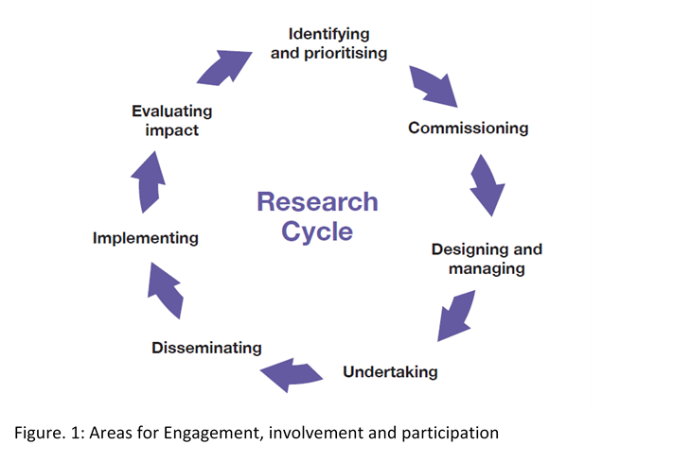

These priorities will then form the basis for discussions with industry partners and researchers about how to take these ideas forward and develop solutions for the identified problems.

This activity will happen in the spring of 2019 and may be repeated in subsequent years, depending on progress against the identified priorities.

How are we going to involve people at other stages of the research process?

Another overlooked stage in the research process for genuine and meaningful involvement is sharing the new knowledge that comes from a research project with other clinicians, academics, policy makers and patients. We would expect the LIG members to help both Research Centres think about the most effective ways of publicising their findings, in order that the best ideas and solutions are taken up quickly within the NHS, so that patients and professionals can benefit as soon as possible. This might involve encouraging people who have taken part in the research itself to contribute to articles and news reports, or recording a video about their experience and how they think the research will benefit them and fellow patients.

How will we know if involvement is making a difference?

As with any activity that is funded by the public it is important to demonstrate that it adds value. The LIG activities will therefore be evaluated to understand what difference they have made to the work of both Research Centres. For the MIC, this assessment of ‘added value’ will be undertaken for each research project that has involved people whether as co-applicants, or reviewers of patient information, or contributors to articles etc. The results of these assessments will be shared across the LIG and within the formal management structures of the MIC.

Funding
Adequate funding has been allocated to PPI as part of the Trauma MIC Project, the management of which will fall under UHB NHS Foundation Trust responsibilities.
Who is leading this work?
On a day-to-day basis, involvement activities for the LIG will be led by the PPI Officer for the SRMRC – Laura Nice. l.nice@bham.ac.uk (Mon and Tues 0121 414 8901; Wed-Fri 0121 371 8533).

Hilary Brown, a Senior Fellow at the University of Birmingham is the PPI academic lead for the MIC and will provide oversight and support. h.i.brown@bham.ac.uk
(07917 065741).

Name yet to be chosen but out to consultation and for purpose of strategy, hereafter referred to as Lay Involvement Group (LIG)

